Title | Assessment Committee work plan 2013 | 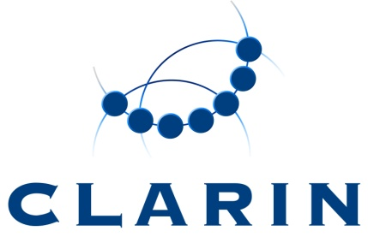
Version | 1
Author(s) | Peter Wittenburg, Dieter Van Uytvanck
Date | 2013-06-05
Status | Early draft for discussion
Distribution | Assessment Committee
ID | CE-2013-0165

Overview chart

 | 1 | 2 | 3 | 4 | 5 | 6 | 7 | 8 | 9 | 10 | 11 | 12
Define Assessment workflow
Assessment workshop
Assessment wave 1
Analysis first wave
Assessment wave 2

Details

Define Assessment workflow

Summary: Agreeing on a working process to perform the assessments by the committee members. Creation of an assessment form.

Responsible: Peter Wittenburg

Assessment workshop

Summary: organize a workshop on the center assessment procedure; have a common meeting of the center committee and the assessment committee. Can be combined with a Federated Content Search workshop.

Responsible: Lene Offersgaard, , Peter Wittenburg

Assessment wave 1 + 2

Summary: 2 batches of requests for center assessments, to be sent to the Assessment Committee. In parallel requests to acquire the Data Seal of Approval.

Responsible: Peter Wittenburg, Lene Offersgaard, Dieter Van Uytvanck

Analysis first wave
Summary: look at the outcomes of the first assessment wave, formulate improvements for the next waves, interact with the centre committee and the assessed centres.

Responsible: Peter Wittenburg

